**BLUE PRINT MODULE**

1. Click Snaps and select Grid

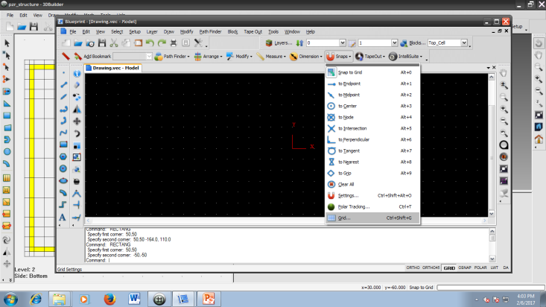

1. Check if the grid values of X and Y are 10.

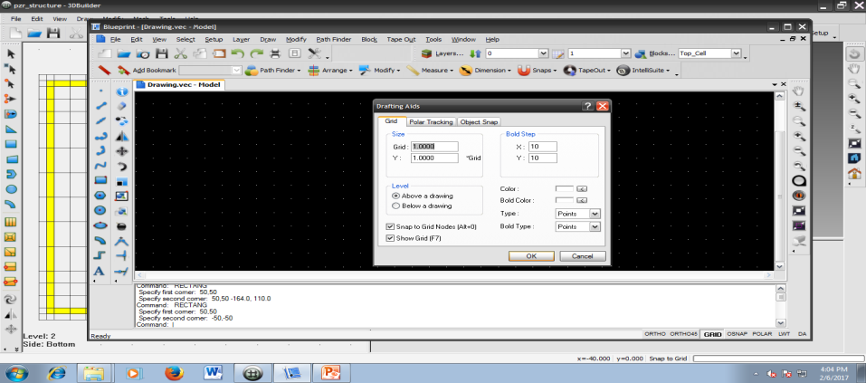

1. Click on the rectangle tool bar and command window will ask for coordinates.

Two coordinates are (50, 50) and (-50,-50)

C:\Users\ornl\Desktop\1\1.tif

You can also select one coordinate manually and click and drag upto the second coordinate to construct a rectangle.

1. Click on Layers and select New

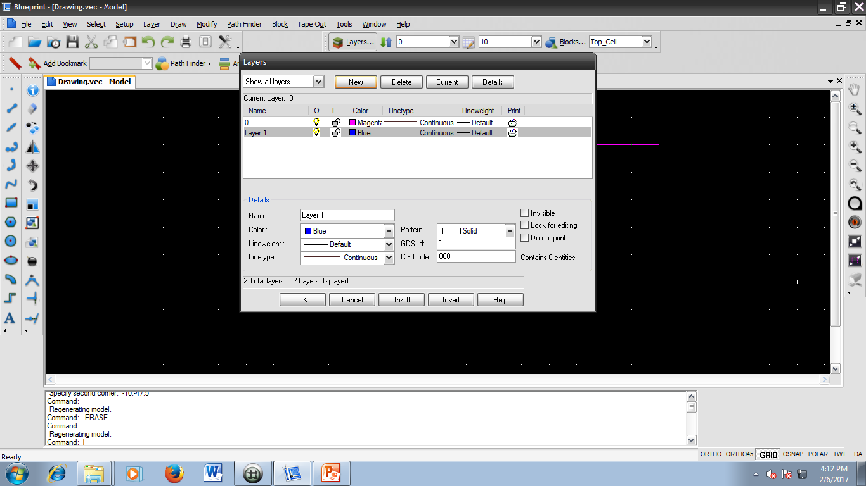

1. Click on the drop down and select Layer 1

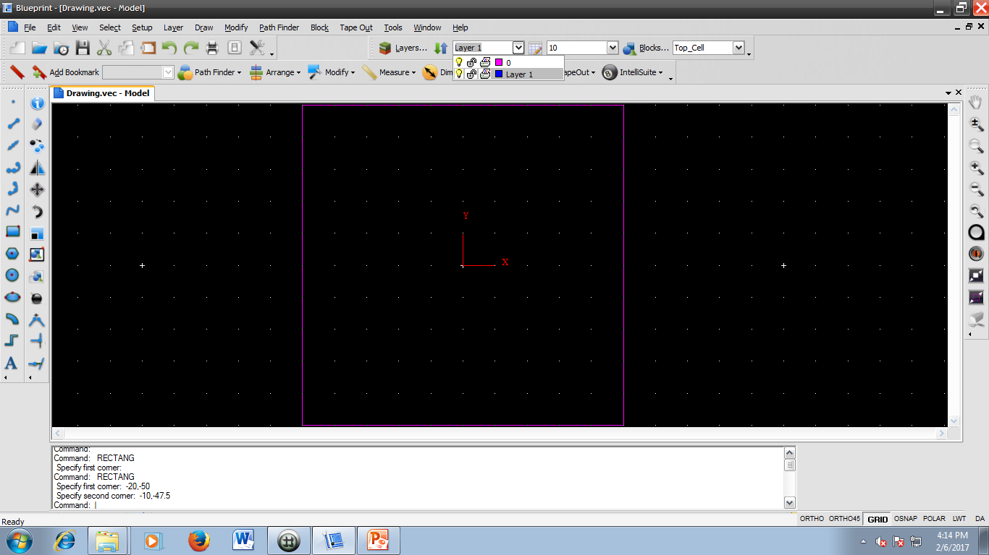

1. Click on the rectangle and follow the instructions. Two coordinates are (-20,-50)and (-10,-47.5)

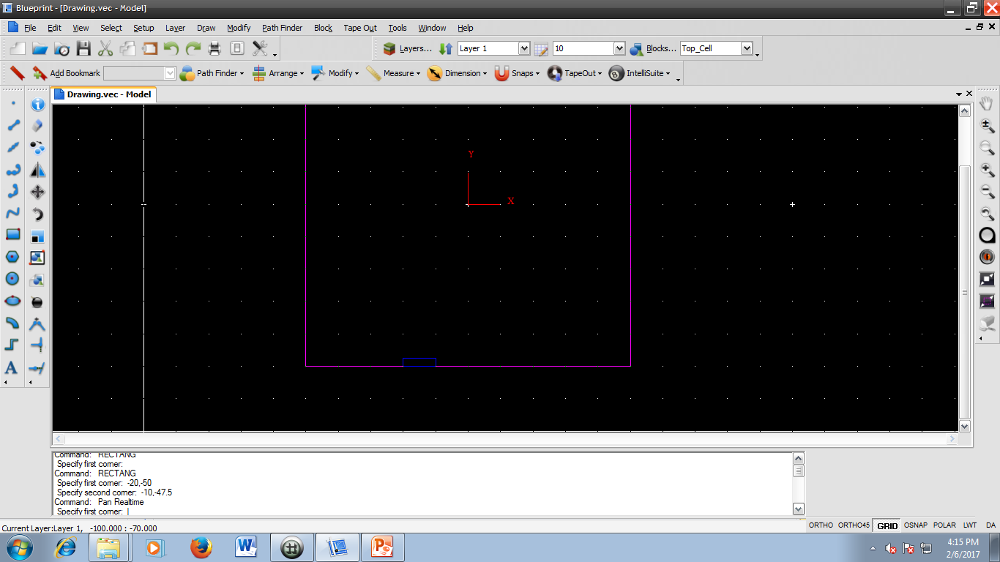

1. In order to repeat the previous step, i.e selecting a rectangle, you can just type enter and give the two coordinates (-10,-45) and (-47.5,-47.5).

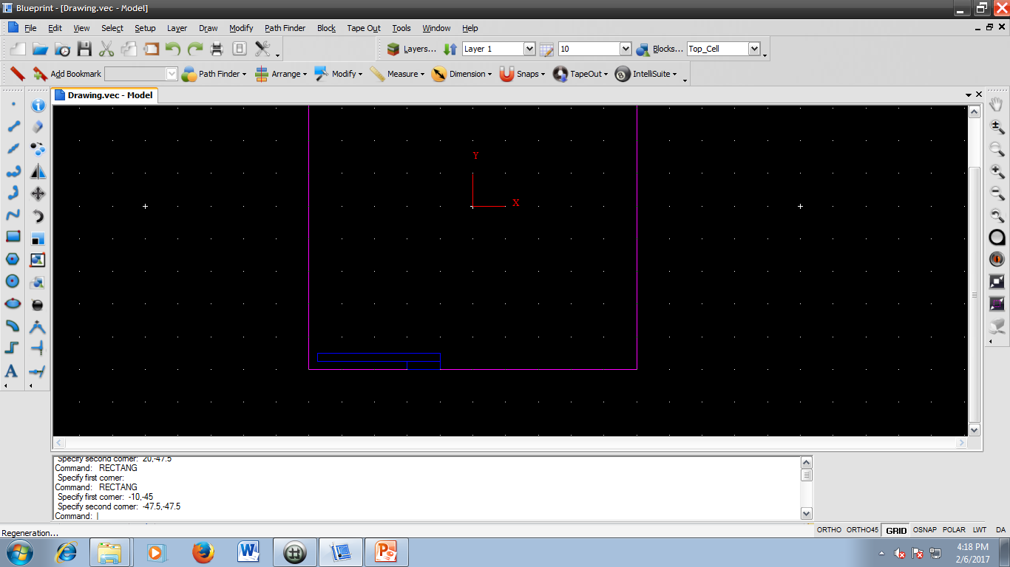

1. Click rectangle and follow the instructions. Two coordinates are (-47.5,-47.5) and (-45,47.5)

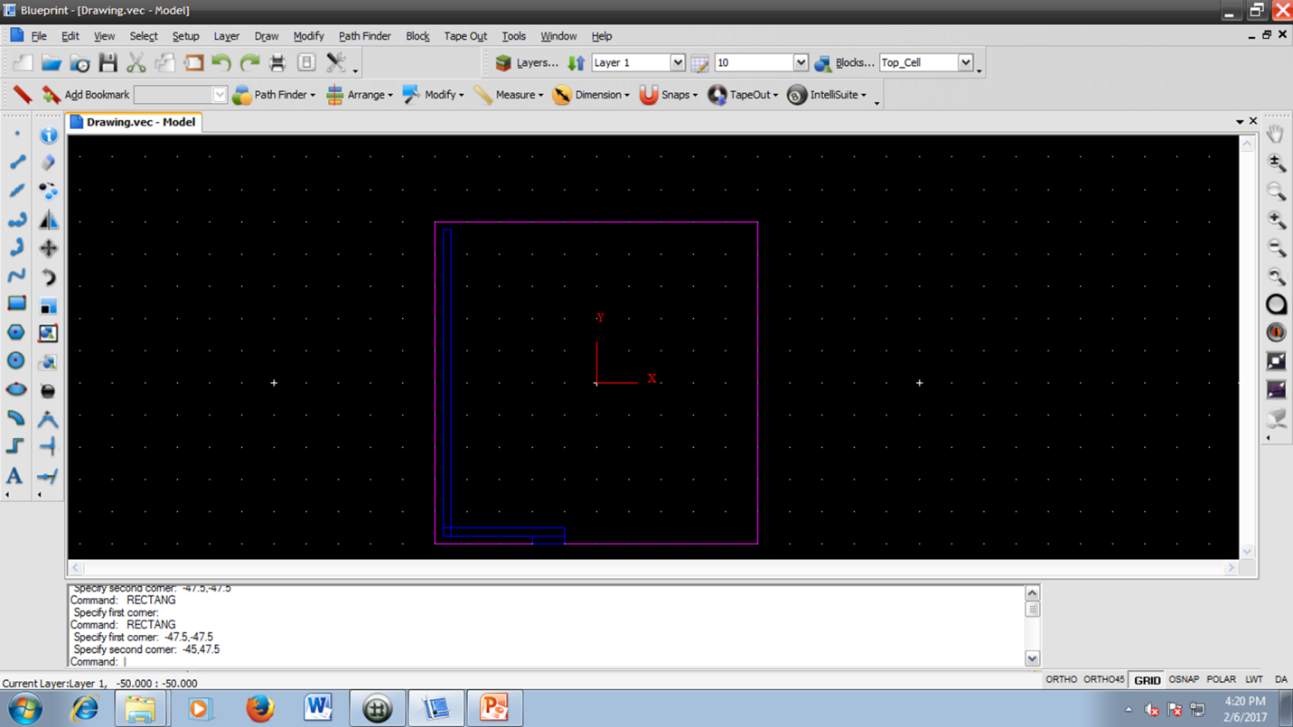

1. Click on mirror and select the last three rectangles drawn and the command window asks for two points of reflection.

First point: (0, 0) and press enter

Second point: (0, 10), press enter.

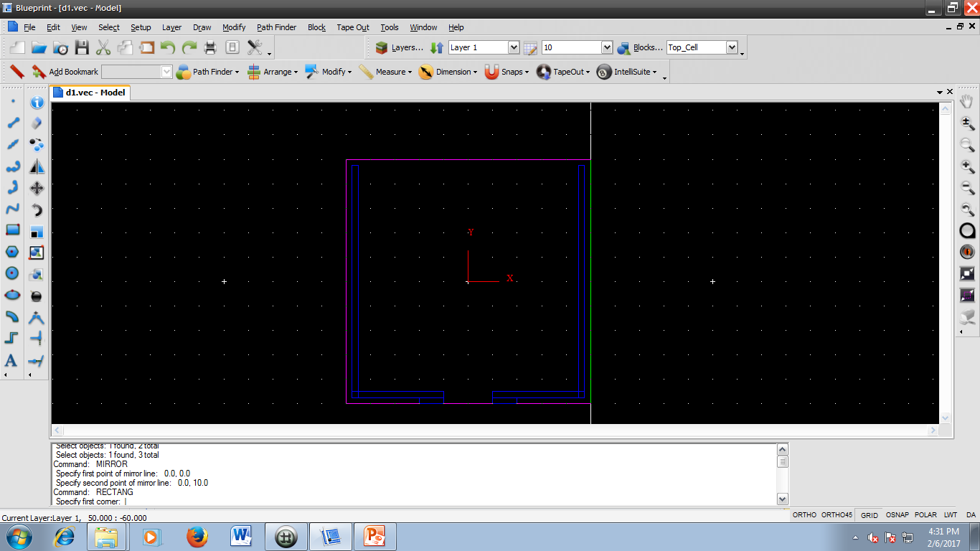

1. Click rectangle and give the two coordinates (-47.5, 47.5) and (47.5, 45).

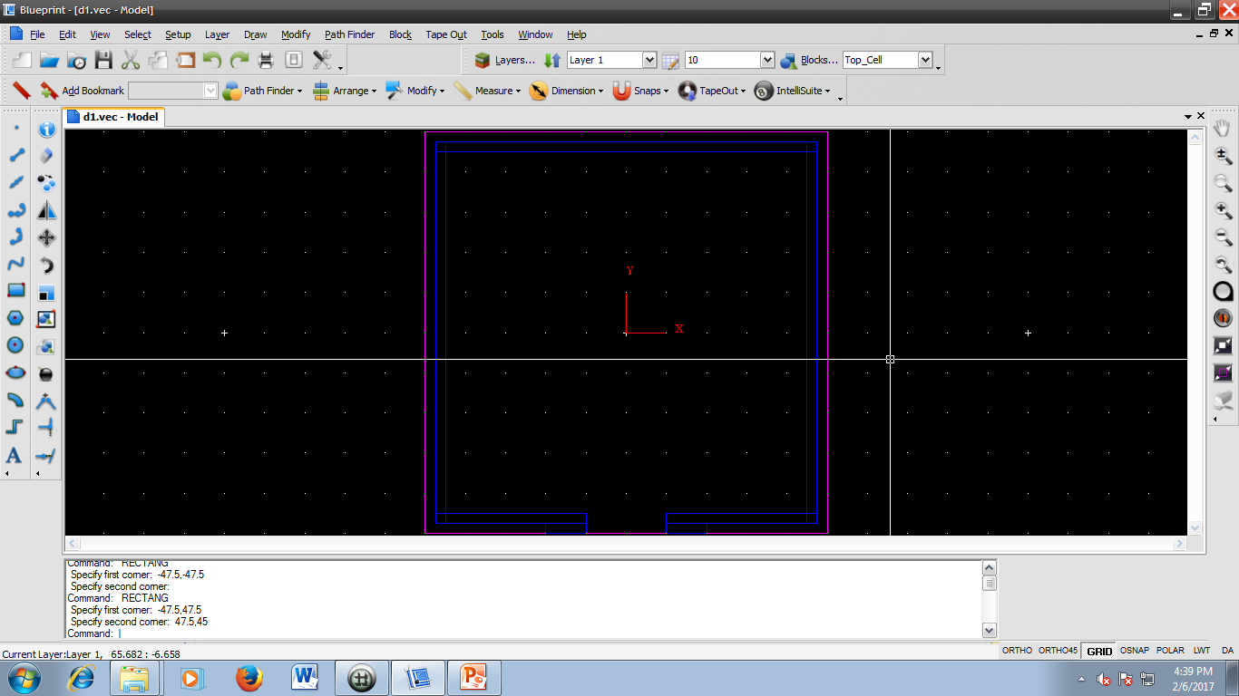

1. Select the rectangles in blue colour (all 7) and click path finder and Union. It will ask for the destination layer. Select Layer 1 (current layer).

